# I-Star Exercise*

1. Identify the routines, habits or outlets that must be in place for you to feel like you have a balanced life right now.
2. Decide which should be the top 8 and fill them in the lines on the star.
3. Circle the number that you think corresponds to how well you are currently doing:

1 = poor to 10 = excellent.

1. Connect the numbers to see your balance level today.

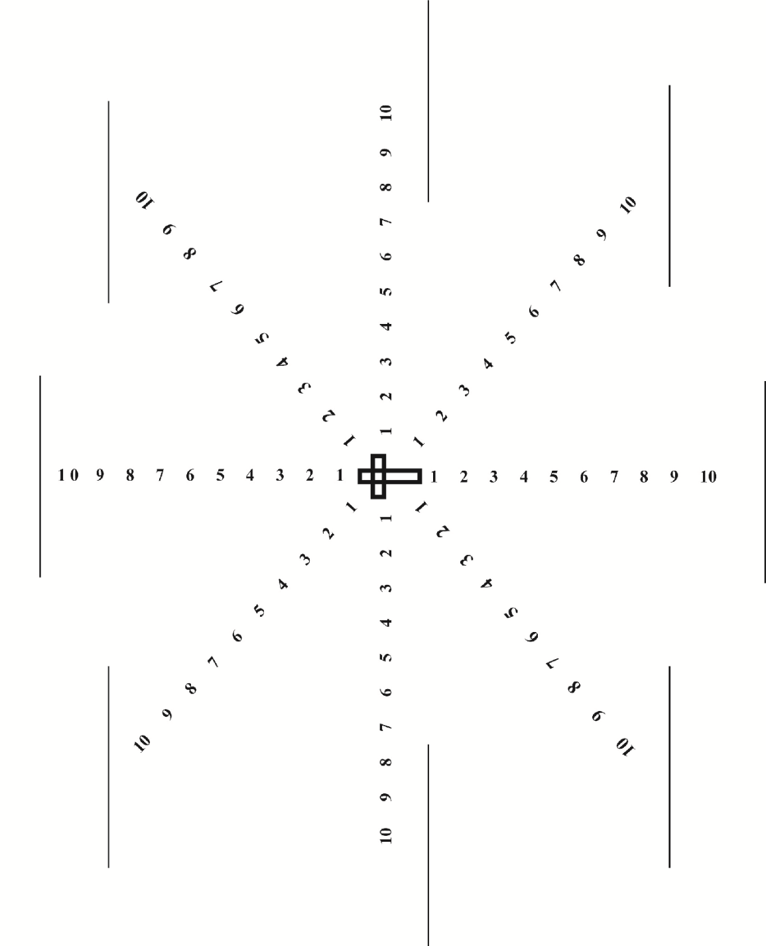

*Married in Mission: A Handbook for Couples in Cross-Cultural Service (2015), by Alexis Kenny, M.A., pg. 38. alexisckenny.wix.com/marriedinmission