# We-Star Exercise*

## For couples to do together

1. Each make a list separately.
2. Identify the routines, habits or outlets that must be in place for you to feel like you have **a *balanced married life*** right now.
3. After you have both finished, compare your lists. Decide together *using both lists*, which should be the top 8. Fill them in the lines on the star.
4. Circle the number that you both think corresponds to how well you are currently doing:

1 = poor to 10 = excellent.

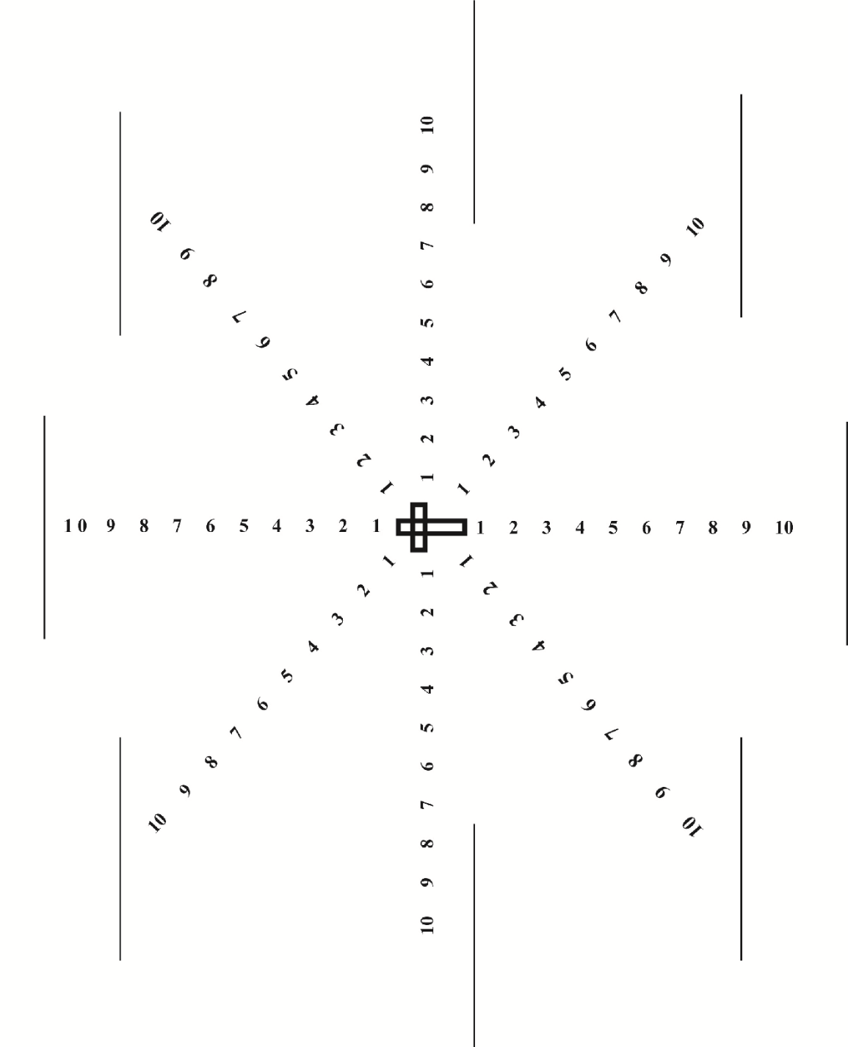

1. Connect the numbers to see your “We” balance level today.

*Married in Mission: A Handbook for Couples in Cross-Cultural Service (2015), by Alexis Kenny, M.A., pg. 38. alexisckenny.wix.com/marriedinmission