***EFCA- ReachNational Compassion & Justice***

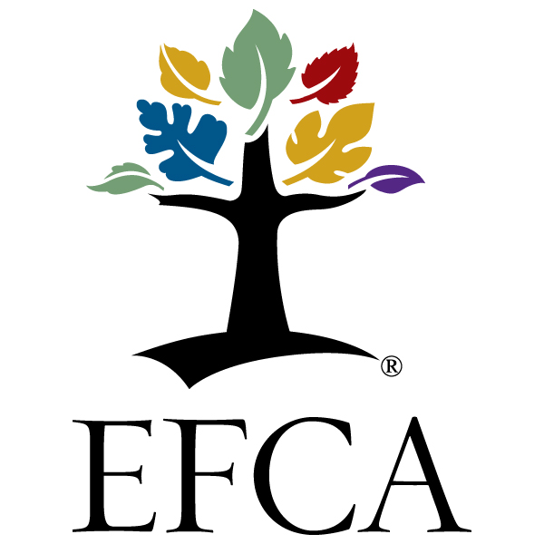

***FAITH COMMUNITY NURSE MINISTRY***

**Foundations of**

**Faith Community Nursing**

**Grow2Serve Online Course**

**13 Weeks, offered 2-3 times per year**

**(visit grow2serve.com/fcn for upcoming dates)**

**A Christ-Centered, Biblically Based Course**

**This Foundations of Faith Community Nurse Preparation course is based on the new curriculum developed through the International Parish Nurse Resource Center (IPNRC)**

**Church Health Center, 1210 Peabody Ave, Memphis, TN 38014**

**Credit:**

Full time participants will receive an IPNRC certificate of course completion and an IPNRC Faith Community Nurse Pin. Provider approved by the California Board of Registered Nursing, # 14885 for 40.5 Contact Hours. Participants must complete all course requirements for CEU credit.

**Registration:**

Each participant must:

1. Be a registered nurse with an active license in the state where they practice.
2. Submit a completed Application Form as soon as possible to hold a place in the class.
3. Submit the full Registration Fee **at least 14 days before the published course start date**. Contact Course Instructor if you need to make other financial arrangements. Applications will be accepted until the class is full.

**Cost:**

$300 Registration Fee

Registration Fee refunds will be sent for cancellations made prior to the published start date of the course.

Questions regarding Registration Fees and additional costs, please contact Paula Lilja at [paula.lilja2@verizon.net](mailto:paula.lilja2@verizon.net).

Registration fees include CEU credit, IPNRC pin and certificate of completion from the IPNRC.

Scholarships for ReachGlobal Missionaries available for $100

**Additional costs**:

**Required**

Students to purchase:

1. The 2014 *Foundations of Faith Community Nursing Curriculum* notebook developed: by the Church health Center, Memphis, TN ($45.00)

Subscription:

1. Journal of Christian Nursing – www.ncf-jcn.org Subscribe before

August 24, 2016 to ensure access to Journal at the beginning of the course.

**Recommended**:

Textbook*:*

1. *Faith Community Health: Scope and Standards of Practice*. By ANA/HMA. (2016 Edition)

**Objectives**:

Participants will have the opportunity to:

1. Describe the theoretical foundation of faith community nursing.
2. Integrate faith and health as central to the faith community nurse role.
3. Demonstrate knowledge, attitude and skills to practice as a beginning faith community nurse.
4. Participate in an inter-collegial peer system of support
5. Identify a network for continuing development and support.
6. Develop a plan for continued spiritual formation to more effectively understand and carry out a faith community nurse ministry.

**Course Content:**

**UNIT I: SPIRITUALITY**

1. History and Philosophy
2. Prayer
3. Healing and Wholeness
4. Self-Care
5. Spiritual Care

**UNIT II: PROFESSIONALISM**

1. Ethical Issues
2. Documenting Practice
3. Legal Aspects
4. Communication and Collaboration
5. Beginning Your Ministry

**UNIT III: WHOLISTIC HEALTH**

1. Health Promotion
2. Behavioral health
3. Transforming Life Issues-Family Violence
4. Transforming Life Issues-Loss, Suffering, and Grief

**UNIT IV: COMMUNITY**

1. Assessment
2. Accessing resources
3. Advocacy
4. Care Coordination

**Speaker:**

Paula Lilja, RN, PN, DNSc, serves as the FCN Coordinator for EFCA- Reach National Compassion and Justice in partnership with the Church Health Center/ IPNRC. She supports the EFCA Faith Community Nurse Network in its effort to connect EFCA nurses for continued education, support and shared resources. Paula established the Faith Community Nurse Ministry at First Evangelical Free Church Fullerton, California.

***Learn more about the Foundations of Faith Community Nursing Course:***

[paula.lilja2@verizon.net](mailto:paula.lilja2@verizon.net) or (281) 532-3060

**Application Form**

**Name**

**Address**

**City**  **State**  **Zip**

**Country**

**E-mail**

**Emergency contact**

**Home phone Cell phone**

**Church/Ministry**

**Nursing license State only---------------- (Please do not send your License Number by Email)**

**Years in Nursing _________**

**Source of information regarding the course ___________________________**

**E-mail the above Application Form to:**

**Paula Lilja**

**3213 Scenic Shore Dr.**

**Seabrook, TX 77586**

[**paula.lilja2@verizon.net**](mailto:paula.lilja2@verizon.net)

**281/532-3060**

**NOTE:**

1. **Orientation Week** to the computer program for the course starts on the published start date of the course and then is followed by 12 weeks of course material.
2. There is a registration page on the Grow2Serve.com web site to allow you to REGISTER for the Online course and make the TUITION PAYMENT by Credit Card until the class is full.
3. The LINK to the registration page will be sent to you by Paula Lilja, the Course Instructor. No one will be able to REGISTER until the above Application form is sent in.
4. Please do not try to register and make a payment at grow2serve.com until you receive the LINK.

Thank you.